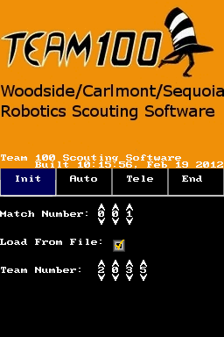 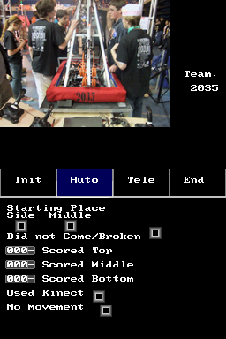

Our Scouting program is made for the Nintendo DS. We are able to view a picture of the robot we are scouting, as well as the preloaded order of the robots for the whole day.

